NYSSLS Daily Lesson Plan
Instructional Unit: Lifecycle of a Star |  |  |  |  | Period(s) of Unit: |  |  | Date:
Materials/Resources/Links: |  |  |  |  |  |  |  | Course:
Special Notes for Lesson:
Standards: Communicate scientific ideas about the way stars, over their life cycle, produce elements.
Science and Engineering Practices  Obtaining, evaluating, and communicating information in 9–12 builds on K–8 experiences and progresses to evaluating the validity and reliability of the claims, methods, and designs. ♣ Communicate scientific ideas (e.g., about phenomena and/or the process of development and the design and performance of a proposed process or system) in multiple formats (including orally, graphically, textually, and mathematically). (HS-ESS1-3) |  |  | Disciplinary Core Idea(s)  The study of stars’ light spectra and brightness is used to identify compositional elements of stars, their movements, and their distances from Earth.  Other than the hydrogen and helium formed at the time of the Big Bang, nuclear fusion within stars produces all atomic nuclei lighter than and including iron, and the process releases electromagnetic energy. Heavier elements are produced when certain massive stars achieve a supernova stage and explode. |  |  |  | Cross Cutting Concepts  In nuclear processes, atoms are not conserved, but the total number of protons plus neutrons is conserved.
Performance Level
NYS Level 5 | NYS Level 4 |  |  | NYS Level 3 |  | NYS Level 2 |  | NYS Level 1
Synthesize valid and reliable scientific information in order to communicate scientific ideas in multiple formats (i.e. orally, graphically, textually, or mathematically) about the way stars, over their life cycles, produce elements. | Communicate scientific ideas about the way stars, over their life cycles, produce elements. |  |  | Describe or identify one scientific idea from a source about how stars, over their life cycles, produce different elements depending on their masses or their life cycle. |  | Identify the given scientific idea that describes how different elements are produced by different types of stars over their life cycle. |  | Given a scientific idea, identify the claim, from those provided, that describes how stars form elements over their life cycle.
Clarification Statement  Emphasis is on how nucleosynthesis varies as a function of the mass of a star and the stage of its lifetime. |  |  |  |  |  | Assessment Boundary  Details of the many different nucleosynthesis pathways for stars of differing masses are not assessed.
Connection to Anchoring Phenomenon:
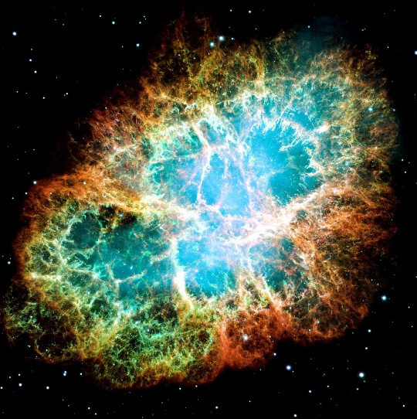
Essential Question(s):
Instructional Strategies & Learning Tasks: Engage, Explore, Explain, Elaborate, Evaluate
Engage: Anchoring phenomenon, demonstration; observations of images, video clip or data… |  | https://youtu.be/px31h7ruU1Y?si=4_BoF2cR7Z8-WZT-  Life Cycle of a Star video  https://youtu.be/k6uODhvkRh8?si=4oVDJAxOIhMkrjmz  How Betelgeuse will explode video
Explore: Students investigate, experiment, hands-on activity…. |  | The life of a star  Life Cycle of a Star poster  HR Diagram Activity
Explain: Students share their observations and evidence to explain their understanding…possible whole group/class discussion… |  | Jet Propulsion Laboratory Herschel Mission Science - Stars (nasa.gov)  Nucleosynthesis in Stars  Lifecycle of a Star  HR Diagram
Elaborate: Students apply the science concepts they’ve just learned… |  | Create a Canva poster, flyer, etc…  Create models of lifespans of stars, nuclear fusion etc…
Evaluate (Formative Assessment): Student learning is evaluated. |  | The life and death of stars  Unit exam

Copy and paste student worksheets below:

Website – New Visions
Discovering New Worlds | New Visions - Science

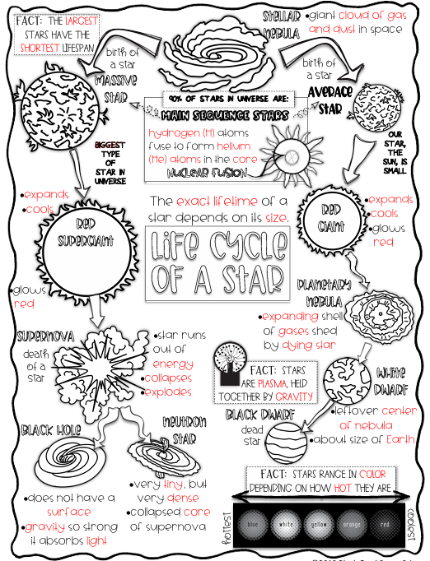
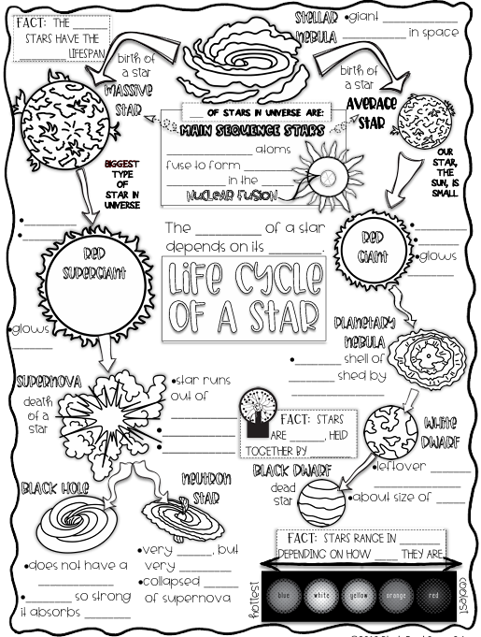

Short Performance Assessment: HS-ESS1-1
Grade Level: High School
Adapted from SNAP

Title | The Life of a Star
Designed by | Paul Andersen | Course(s) | High School
This work is licensed under a Creative Commons Attribution-NonCommercial 4.0 International License.

Performance  Expectation | HS-ESS1-1: Develop a model based on evidence to illustrate the life span of the sun and the role of nuclear fusion in the sun’s core to release energy in the form of radiation.  Clarification Statement: Emphasis is on the energy transfer mechanisms that allow energy from nuclear fusion in the sun’s core to reach Earth. Examples of evidence for the model include observations of the masses and lifetimes of other stars, as well as the ways that the sun’s radiation varies due to sudden solar flares (“space weather”), the 11-year sunspot cycle, and non-cyclic variations over centuries.  Assessment Boundary: Assessment does not include details of the atomic and subatomic processes involved with the sun’s nuclear fusion.

Science and  Engineering Practice | Developing and Using Models  • Develop a model based on evidence to illustrate the relationships between systems or between components of a system.
Disciplinary Core Ideas | ESS1.A: The Universe and Its Stars  • The star called the sun is changing and will burn out over a lifespan of approximately 10 billion years.  PS3.D: Energy in Chemical Processes and Everyday Life  • Nuclear fusion processes in the center of the sun release the energy that ultimately reaches Earth as radiation. (secondary)
Crosscutting Concept | Scale, Proportion, and Quantity  • The significance of a phenomenon is dependent on the scale, proportion, and quantity at which it occurs.

Student Performance | 1. Components of the model  2. Relationships  3. Connections

Name________________________________

The mass of a star is related to several other characteristics of the star. In this assessment you will be developing a model to explain this mechanism.

- Look at each figure (graphs or tables) on the next two pages and use them to complete the questions on the table below.

Figure | What patterns do you observe?  Be sure to use data from the figure to support your answer
Figure 1: Lifetime
Figure 2: Surface Temperature and Spectral Type
Figure 3: Luminosity

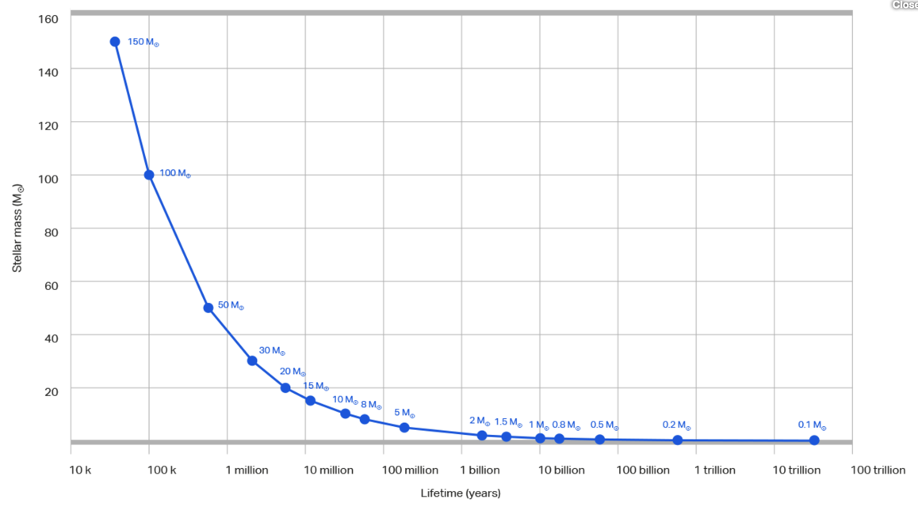
Figure 1 - Martin Silvertant - Quora

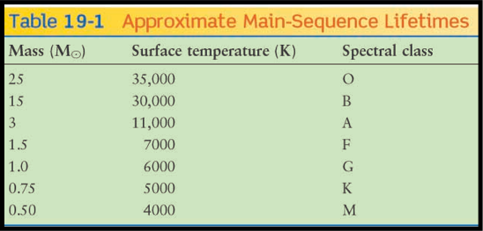
Figure 2 - Source

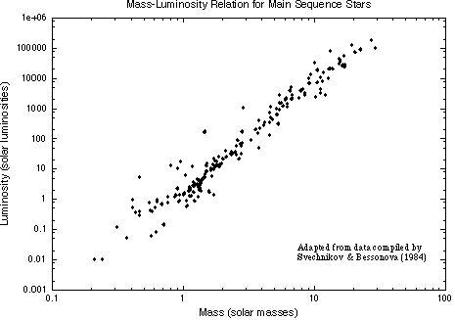
Figure 3 - https://www.astronomynotes.com/starsun/s8.htm

2. In the space provided develop a model based on the evidence above to illustrate the lifespan of a star and the role of nuclear fusion in the star’s core to release energy in the form of radiation.

Your model must include the following components: hydrogen, helium, energy, fusion, mass, lifespan

Assessment Rubric* - Question 1
 | Emerging | Developing | Approaching  Proficiency | Excelling
Description of performance
Sample student responses

Assessment Rubric* - Question 2
 | Emerging | Developing | Approaching  Proficiency | Excelling
Description of performance
Sample student responses

Insert additional Assessment Rubrics (if needed) here.

Short Performance Assessment: HS-ESS1-1
Grade Level: High School
Adapted from SNAP

Title | Why the Sun will die and what happens to Earth?
Designed by | Annette Miller and Katie Agen  Buffalo Public Schools | Course(s) | Earth Science
This work is licensed under a Creative Commons Attribution-NonCommercial 4.0 International License.

Performance  Expectation | HS-ESS1-1: Develop a model based on evidence to illustrate the life span of the sun and the role of nuclear fusion in the sun’s core to release energy in the form of radiation.  Clarification Statement: Emphasis is on the energy transfer mechanisms that allow energy from nuclear fusion in the sun’s core to reach Earth. Examples of evidence for the model include observations of the masses and lifetimes of other stars, as well as the ways that the sun’s radiation varies due to sudden solar flares (“space weather”), the 11-year sunspot cycle, and non-cyclic variations over centuries.  Assessment Boundary: Assessment does not include details of the atomic and subatomic processes involved with the sun’s nuclear fusion.

Science and  Engineering Practice | Developing and Using Models  • Develop a model based on evidence to illustrate the relationships between systems or between components of a system.
Disciplinary Core Ideas | ESS1.A: The Universe and Its Stars  • The star called the sun is changing and will burn out over a lifespan of approximately 10 billion years.  PS3.D: Energy in Chemical Processes and Everyday Life  • Nuclear fusion processes in the center of the sun release the energy that ultimately reaches Earth as radiation. (secondary)
Crosscutting Concept | Scale, Proportion, and Quantity  • The significance of a phenomenon is dependent on the scale, proportion, and quantity at which it occurs.

Student Performance | 1. Components of the model  2. Relationships  3. Connections

Name________________________________

Why the Sun will Die and What Happens to Earth?
Part 1 - Developing a Model of the Lifespan of our Sun
Watch the short video: How the sun will die and what happens to Earth?

Our Sun is a medium-sized star and is expected to have a total life span of about 10 billion years. It started the process of generating energy about 4.6 billion years ago and has been gradually brightening since birth. In 3 or 4 billion years the Sun will have enough core density to swell into a red giant (frying the Earth) and will slowly blow away some of its outer layer. In about 5 billion years, it will no longer be able to continue to generate enough energy and will shrink to a gradually cooling white dwarf. What is causing all of these changes to take place?

- Look at each figure (graphs or tables) on the next two pages about properties of stars and use them to complete the questions on the table below.

Figure | What patterns do you observe? | What is your evidence?  Be sure to use data from the figure to support your answer
Figure 1: Lifetime
Figure 2: Surface Temperature and Spectral Type

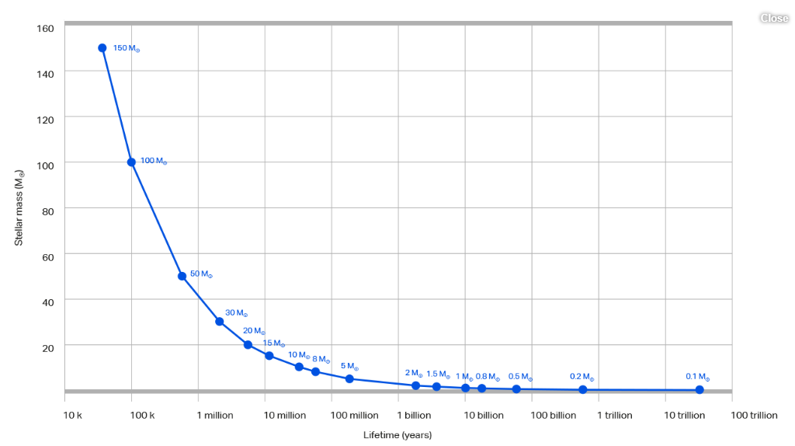
Figure 1 - Martin Silvertant - Quora

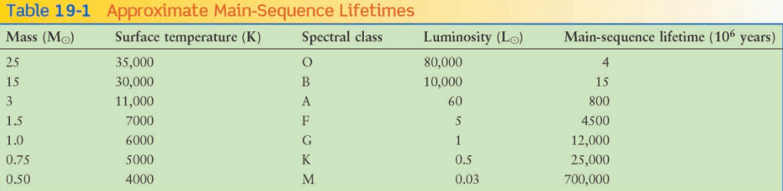
Figure 2 Data source

2. In the space provided, develop a model based on the evidence above to illustrate the lifespan of a star, including information about the scale of the star’s mass at various stages of its life cycle.

Your model must include the following components: mass, temperature and time (lifespan)

Part 2: Connections between the sun’s processes and processes on Earth
As the sun goes through its life cycle, many changes will take place that will affect the ability of the Earth to support life. In 1.1 billion years from now, the Sun will be 10% brighter than it is today, and this increase in luminosity will also mean an increase in heat energy, which Earth’s atmosphere will absorb. This will trigger a moist greenhouse effect here on Earth that is similar to the runaway warming that turned Venus into the hellish environment we see there today. In 3.5 billion years from now, the Sun will be 40% brighter than it is right now. This increase will cause the oceans to boil, the ice caps to permanently melt, and all water vapor in the atmosphere to be lost to space. Under these conditions, life as we know it will be unable to survive anywhere on the surface. In short, planet Earth will come to be another hot, dry Venus. www.universetoday.com
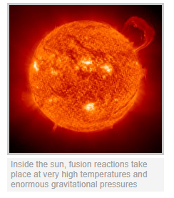
Figure 3 https://fusionforenergy.europa.eu/understandingfusion/

3. Based on the evidence above create a model that explains the role of nuclear fusion in the star’s core as the cause of the changes to the Sun as described in the passage above. .

Your model must include the following components: hydrogen, helium, energy, fusion, mass, temperature, time (lifespan)

The following table shows the percent by volume and mass of the elements found in the Sun.

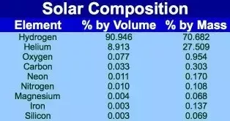
Figure 4 source

4. Use the model you created in number 3 and the data in figure 4 to predict how the relative proportions of hydrogen to helium change as the sun ages and changes in mass, temperature and luminosity. To do this use the following key to color in the grids below to represent hydrogen to helium in the Sun at different points in its life cycle.
White = Hydrogen
Colored in = Helium

Describe your reasoning for coloring/not coloring in the boxes for each stage of the life cycle above.
Part 3 Relationships between the Sun and Earth
Throughout its lifespan (approximately every eleven years), solar activity increases and a phenomenon called solar flares occur on the Sun’s surface. View the following video and read the passage below to learn more about solar flares then answer the question that follows:

Video: What are Solar Flares?

The Effect of Solar Flares on Earth

The explosive heat of a solar flare can't make it all the way to our globe, but electromagnetic radiation and energetic particles certainly can. Solar flares can temporarily alter the upper atmosphere, creating disruptions with signal transmission from, say, a GPS satellite to Earth causing it to be off by many yards. (source NASA.gov) A 132-page study by the National Academy of Sciences about the potential global impact of a super large solar flare, such as the "Carrington flare" of 1859 (which was also the first solar flare ever observed, and named after Richard Carrington, one of the observers). This event caused a severe geomagnetic storm, which disrupted telegraph communications and had it occurred today, its impact on electrical systems, telecommunications and commerce would be catastrophic. (source Solar Center at Stanford.edu)

5. In the space provided, describe the process of radiation and how the energy released by the Sun during a solar flare reaches the Earth’s surface.

Despite the Earth’s fate of probable destruction due to the ending of the life of the Sun, the energy produced by the Sun is at the center of biological and chemical processes here on Earth today. Without it, the life cycle of plants and animals would end, the circadian rhythms of all terrestrial creatures would be disrupted; and in time, all life on Earth would cease to exist. source Universetoday.com

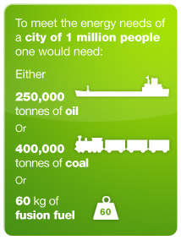
6. Is it possible to generate the amount of energy radiated to Earth from the Sun using the chemical processes that occur on Earth? Using your model and the information inferred from figure 5, describe the differences in the quantity of energy produced by nuclear processes in the Sun and chemical processes on Earth?

Assessment Rubric* - Question 1
 | Emerging | Developing | Approaching  Proficiency | Excelling
Description of performance
Sample student responses

Assessment Rubric* - Question 2
 | Emerging | Developing | Approaching  Proficiency | Excelling
Description of performance
Sample student responses

Assessment Rubric* - Question 3
 | Emerging | Developing | Approaching  Proficiency | Excelling
Description of performance
Sample student responses

Assessment Rubric* - Question 4
 | Emerging | Developing | Approaching  Proficiency | Excelling
Description of performance
Sample student responses

Assessment Rubric* - Question 5
 | Emerging | Developing | Approaching  Proficiency | Excelling
Description of performance
Sample student responses

Assessment Rubric* - Question 6
 | Emerging | Developing | Approaching  Proficiency | Excelling
Description of performance
Sample student responses

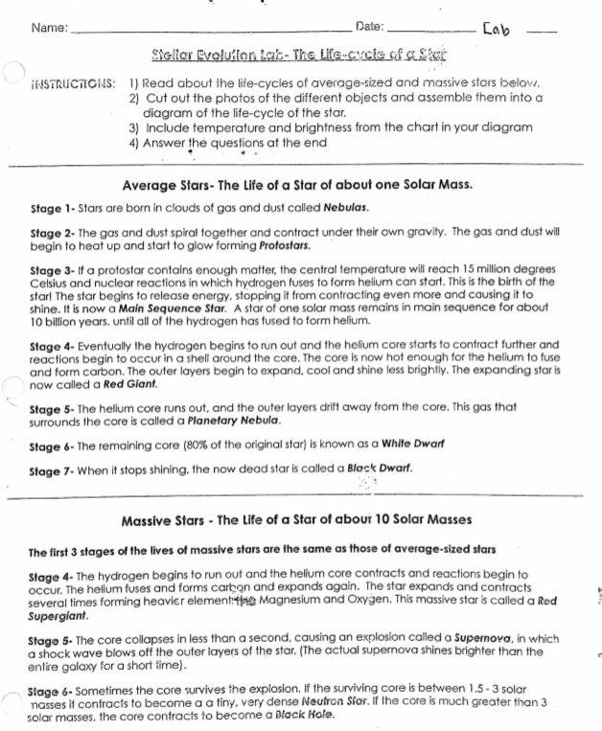
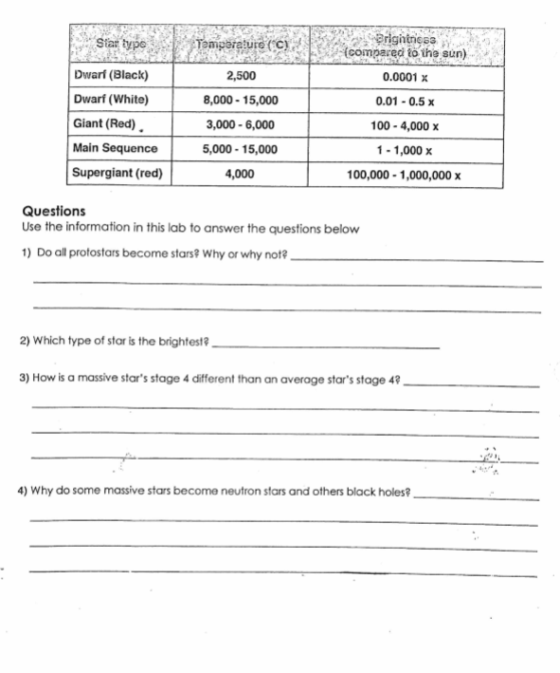
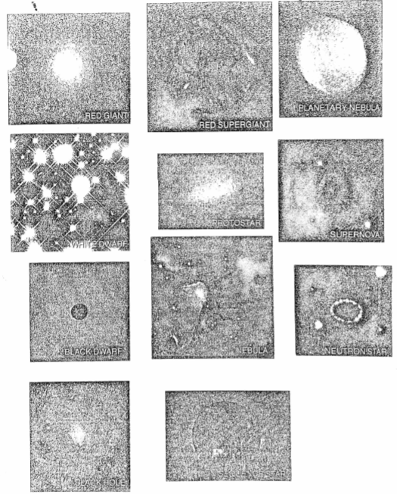
*Students can also do this lab/activity using Canva

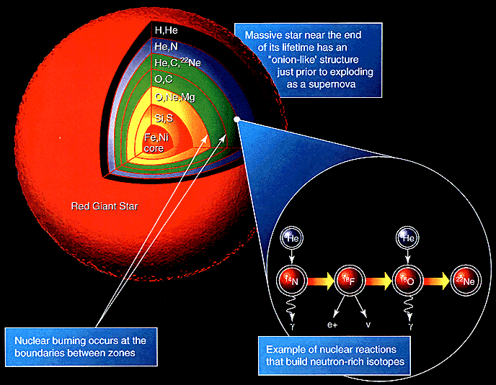
nucleosynthesis (daviddarling.info)

Nucleosynthesis is the buildup of heavy elements from lighter ones by nuclear fusion. Helium and some lithium was produced by cosmic nucleosynthesis just after the Big Bang, but today most element-building nucleosynthesis takes place in stars.

Stellar nucleosynthesis converts hydrogen into helium, either by the proton-proton chain or by the carbon-nitrogen-oxygen cycle. As a star evolves, a contracting superdense core of helium is produced from the conversion of hydrogen nuclei into helium nuclei. Eventually, the temperature and pressure inside the core become high enough for helium to begin fusing into carbon. If the star has more than about twice the Sun's mass, a sequence of nuclear reactions then produces heavier elements such as oxygen, silicon, magnesium, potassium, and iron. Successively heavier elements, as far as iron (in the most massive stars) are built up in later stages of stellar evolution by the triple-alpha process. The heaviest elements of all are produced by explosive nucleosynthesis in supernova explosions, by mechanisms such as the p-process, r-process, and s-process.
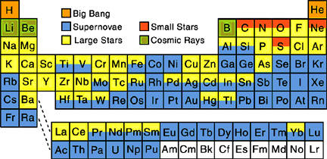
Stellar Nucleosynthesis: How Stars Make All of the Elements (thoughtco.com)

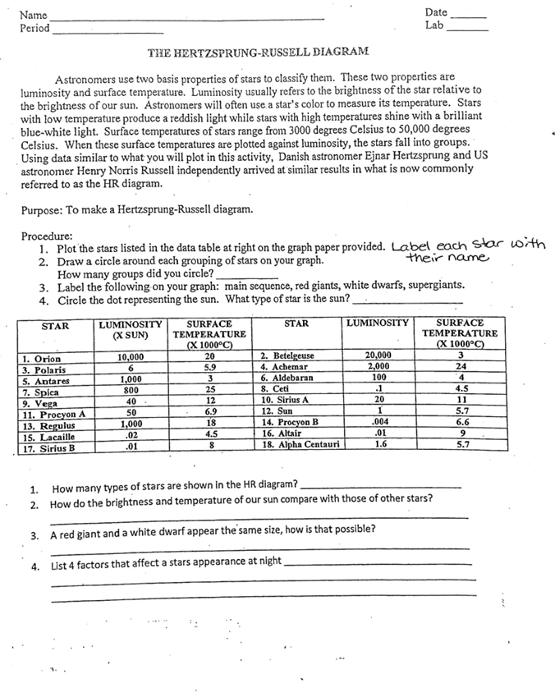


Short Performance Assessment: HS-ESS1-1
Grade Level: High School
Adapted from SNAP

Title | The Life and Death of Stars
Designed by | Paul Andersen | Course(s) | HS NGSS Earth and Space
This work is licensed under a Creative Commons Attribution-NonCommercial 4.0 International License.

Performance  Expectation | HS-ESS1-1: Develop a model based on evidence to illustrate the life span of the sun and the role of nuclear fusion in the sun’s core to release energy in the form of radiation.  Clarification Statement: Emphasis is on the energy transfer mechanisms that allow energy from nuclear fusion in the sun’s core to reach Earth. Examples of evidence for the model include observations of the masses and lifetimes of other stars, as well as the ways that the sun’s radiation varies due to sudden solar flares (“space weather”), the 11-year sunspot cycle, and non-cyclic variations over centuries.  Assessment Boundary: Assessment does not include details of the atomic and subatomic processes involved with the sun’s nuclear fusion.

Science and  Engineering Practice | Developing and Using Models  • Develop a model based on evidence to illustrate the relationships between systems or between components of a system.
Disciplinary Core Ideas | ESS1.A: The Universe and Its Stars  • The star called the sun is changing and will burn out over a lifespan of approximately 10 billion years.  PS3.D: Energy in Chemical Processes and Everyday Life  • Nuclear fusion processes in the center of the sun release the energy that ultimately reaches Earth as radiation. (secondary)
Crosscutting Concept | Scale, Proportion, and Quantity  • The significance of a phenomenon is dependent on the scale, proportion, and quantity at which it occurs.

Student Performance | 1. Components of the model  2. Relationships  3. Connections

Name________________________________
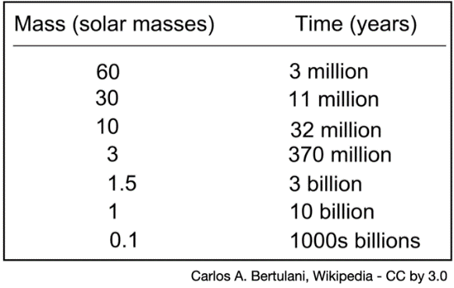
Background:

Unlike humans the life and death of a star is determined by one factor, the mass of the star. The data table to the right shows the lifespan of stars based on their mass. The model below shows what stars will become as they grow older and eventually die.

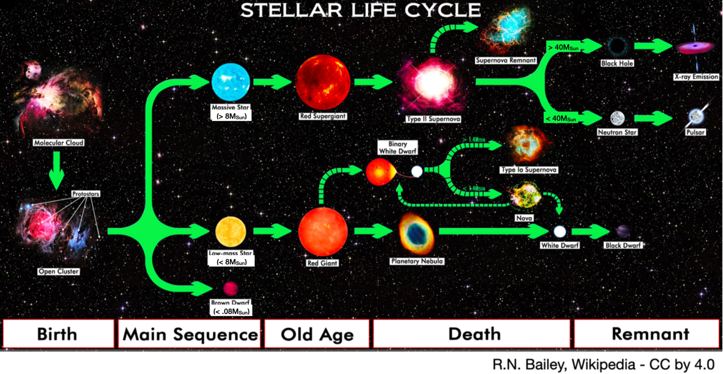

- Use the data table and model above to approximate the lifespan and evolution of three “nearby” stars.

Name | Image | Mass | Lifespan (years) | Old age | Remnant
Sun | 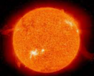 | 1 solar mass  (1.98 x 1030 kg) | 10 billion years | Red giant | Black dwarf
Proxima centauri | 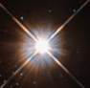 | .123 solar masses
Luhman 16 | 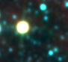 | .032 solar masses
WR 25 | 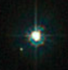 | 98 solar masses
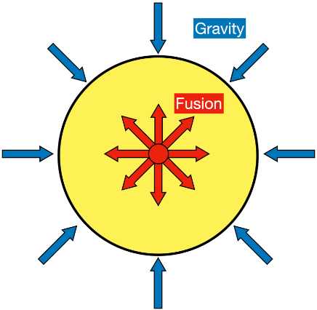
Why do Big Stars Die Faster?

The life of a star is a balance between the gravitational forces (contraction) and fusion (expansion). Larger stars have more mass and therefore larger gravitational forces. These forces lead to more contraction and a greater density and temperature of the matter inside the star. This increases the rate of nuclear fusion. A massive star, like WR 25, can use up all of its fuel in just a few million years.

- Use your understanding of nuclear fusion to develop a model that explains why more massive stars, like WR 25 die more quickly than less massive stars, like the Sun. Your model should include the following components:
  - Hydrogen as star’s fuel
  - Helium and energy as products of fusion
  - Mass and lifespan of two stars

Model
Develop a proportional matter model based on the evidence that massive stars die more quickly than less massive stars like the Sun. | 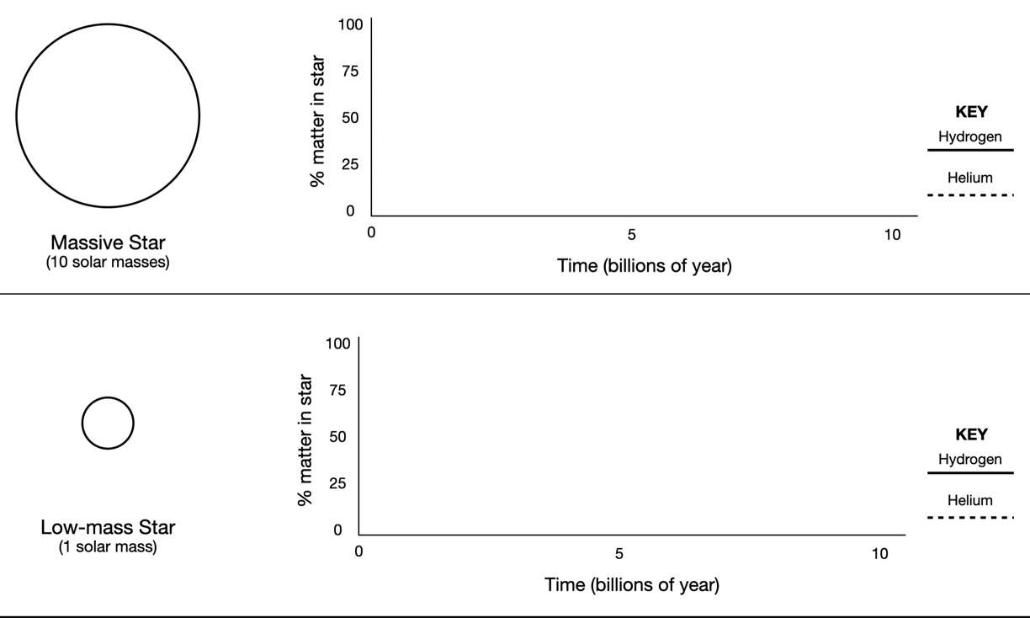
Explanation
Use your model to explain why massive stars die more quickly than less massive stars like the Sun.
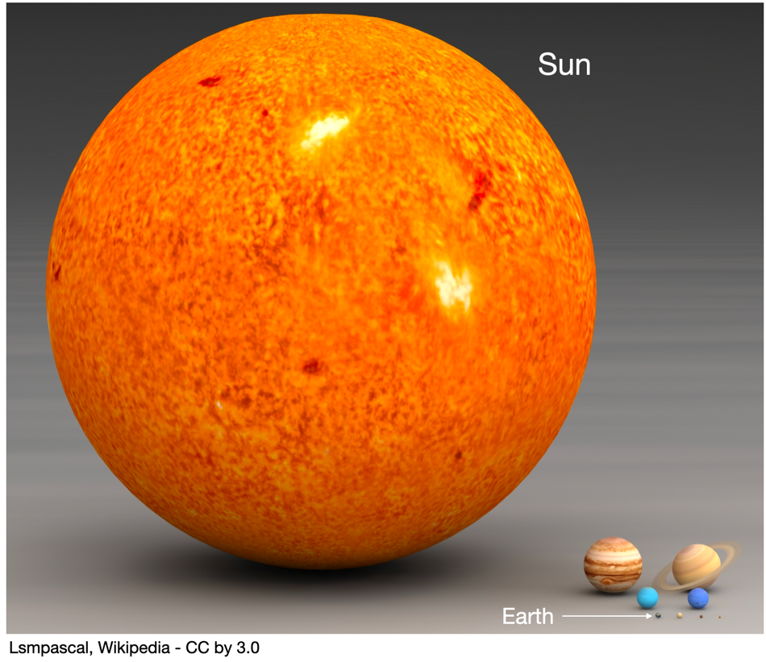
- The Earth is massive but it is 333,000 times less massive than the Sun. Use your understanding of nuclear fusion and chemical processes to explain why life on our planet depends on the Sun as a source of energy.

